**ULTRASONIC SENSORS**

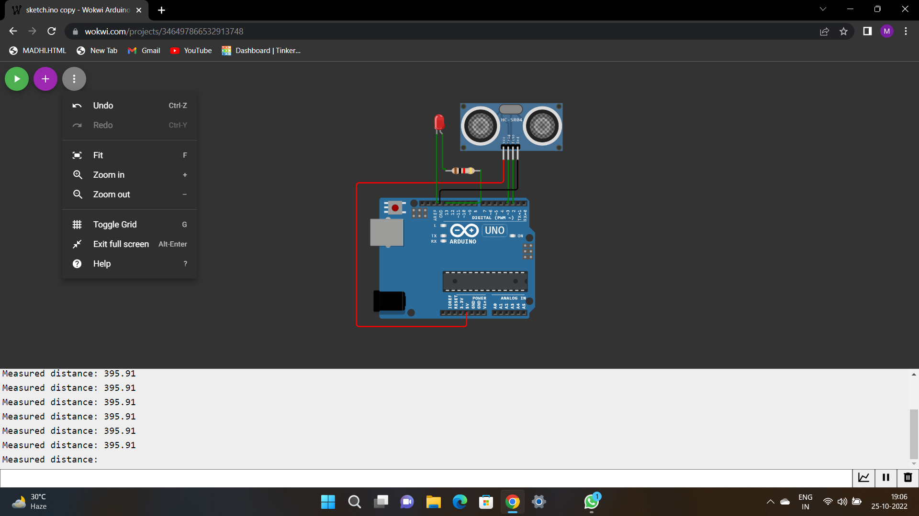

#define ECHO_PIN 2

#define TRIG_PIN 3

void setup() {

Serial.begin(115200);

pinMode(LED_BUILTIN,OUTPUT);

pinMode(TRIG_PIN, OUTPUT);

pinMode(ECHO_PIN, INPUT);

}

float readDistanceCM() {

digitalWrite(TRIG_PIN, LOW);

delayMicroseconds(2);

digitalWrite(TRIG_PIN, HIGH);

delayMicroseconds(10);

digitalWrite(TRIG_PIN, LOW);

int duration = pulseIn(ECHO_PIN, HIGH);

return duration * 0.034/2;

}

void loop() {

float distance = readDistanceCM();

bool isNearby = distance < 100 ;

digitalWrite(LED_BUILTIN, isNearby);

Serial.print("Measured distance: ");

Serial.println(readDistanceCM());

delay(100);

}

<https://wokwi.com/projects/346497866532913748>